Concentration-ΔQTc analysis of Dofetilide (preliminary report)
Generated on 12 mars, 2025

List of abbreviations
Abbreviation | Description
AIC | Akaike information criterion
BIC | Bayesian information criterion
BICc | Corrected Bayesian information criterion
CI | Confidence interval
Cmax | Maximum concentration
ECG | Electrocardiogram
Emax | Maximum effect
GOF | Goodness of fit
HR | Heart rate (bpm)
LLOQ | Lower limit of quantification
ms | Milliseconds
QT | QT interval on the ECG (ms)
QTc | QT interval corrected for heart rate (ms)
RSE | Relative standard error (%)
Tmax | Time of maximum concentration (h)
ΔHR | Heart rate change from baseline (bpm)
ΔQTc | QT interval duration change from baseline (ms)

List of figures
To be added manually

List of tables
To be added manually

1. Executive Summary
This document summarizes the concentration-QT analysis for Dofetilide. The data originate from the clinical study/studies [add study number(s) or name(s)]. The analyses are based on the ICH E14 guidances [1, 2] for concentration-QTc modeling and follow the white paper by Garnett et al. [3].
The analyses were structured as follows:
- Exploratory data analysis (data summary, QT/QTc, heart rate correction, baseline QTc, ΔQTc, and concentration-time)
- Model assumption assessments (heart-rate independence from drug concentration, QTc independence from heart rate, linearity of the concentration-QTc relationship, immediate effect of concentration change on ΔQTc change)
- Modeling results (model fit, parameter estimates, goodness of fit)
- Predictions (derivation of ΔΔQTc prediction intervals), including assessment of the 10-ms threshold

2. Methods
Concentration values below the lower limit of quantification (LLOQ) were [define how BLQ concentrations are handled]. Time generally denotes scheduled (per-protocol) time. Actual times with large deviations from scheduled times should not be included in the analyses due to the nature of the exploratory analyses and the regression models.
The primary objective, the concentration-QT analysis based on modeling, follows the white paper [3] and uses a linear model. Alternative non-linear models were compared using the corrected Bayesian information criterion (BICc) for mixed-effects models [4]. Lower BICc values indicate better model fits, balancing goodness of fit to the data and model complexity (number of parameters). Monolix [5] was used for model fitting using the R lixoftConnectors, R was used for data processing, summaries, and visualization [6, 7].

3. Exploratory data analysis
The aim of this section is to assess the quality of the data and detect extreme values that might be implausible.

3.1 Data summary
The study comprised 2 treatments with a total of 22 subjects. Pharmacokinetic samples and ECGs were collected at -0.5, 0.5, 1, 1.5, 2, 2.5, 3, 3.5, 4, 5, 6, 7, 8, 12, 14, 24 h after start of dosing. In total, 704 observations were available for analysis. At each time point for each subject, [add number of replicates] ECGs were recorded, and the mean QTc interval duration values reported. Table 1 provides a summary. The QT correction for heart rate corresponds to the [Fridericia correction (change here if another correction method was used)] [8].
Treatment | Number of subjects/  measurements | Concentration  range (pg/mL) | Mean QTc  (ms)  [range] | Geometric Cmax mean  (pg/mL)  [range]
Placebo | 22/352 |  | 388.6  [349.7 - 438.9]
Dofetilide | 22/352 | 0.0 - 3270.0 | 424.6  [364.7 - 551.0] | 2709.9  [2080.0 - 3270.0]
Table 1: Number of subjects, number of measurements, and value ranges of concentration and QTc by treatment group.

3.2 Exploratory analysis of QT and QTc
QT and QTc interval durations are shown vs time (Figure 1).
Figure 1: QT (A) and QTc (B) interval duration vs time.
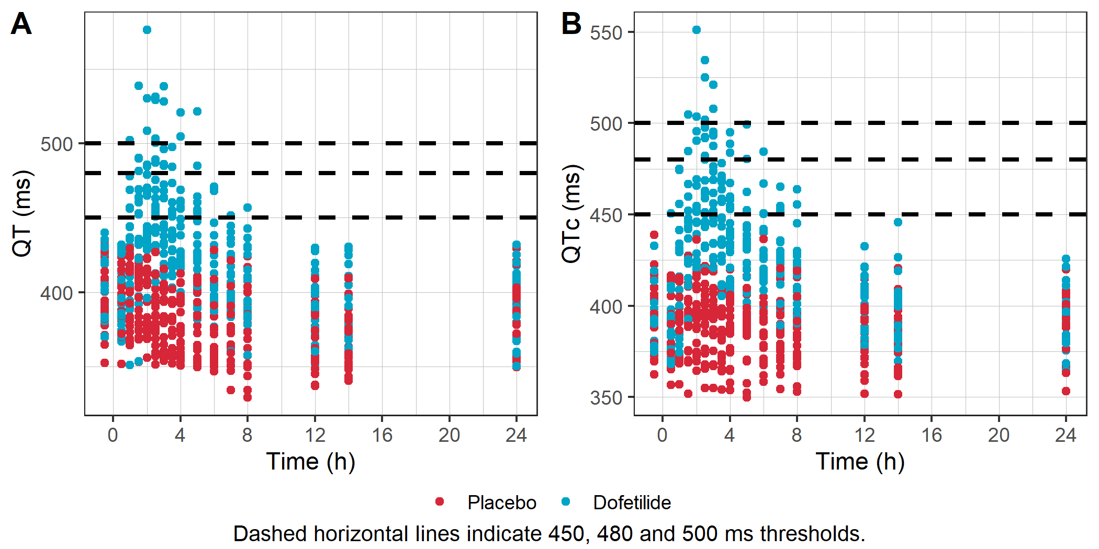
Table 2 contains a summary of different levels of QTc measurements (below 450 ms, between 450 and 480 ms, between 480 and 500 ms, and above 500 ms).
Treatment | ≤ 450 ms | > 450 and ≤ 480 ms | > 480 and ≤ 500 ms | > 500 ms
Placebo | 352 (100%) | 0 (0%) | 0 (0%) | 0 (0%)
Dofetilide | 274 (77.8%) | 52 (14.8%) | 18 (5.1%) | 8 (2.3%)
Table 2: Number of QTc measurements below or above threshold values, by treatment.
Distributions of QTc interval durations overall and by treatment allow for a visual comparison between treatments (Figure 2).
Figure 2: Distribution of QTc interval duration, across treatments (A) and by treatment (B).
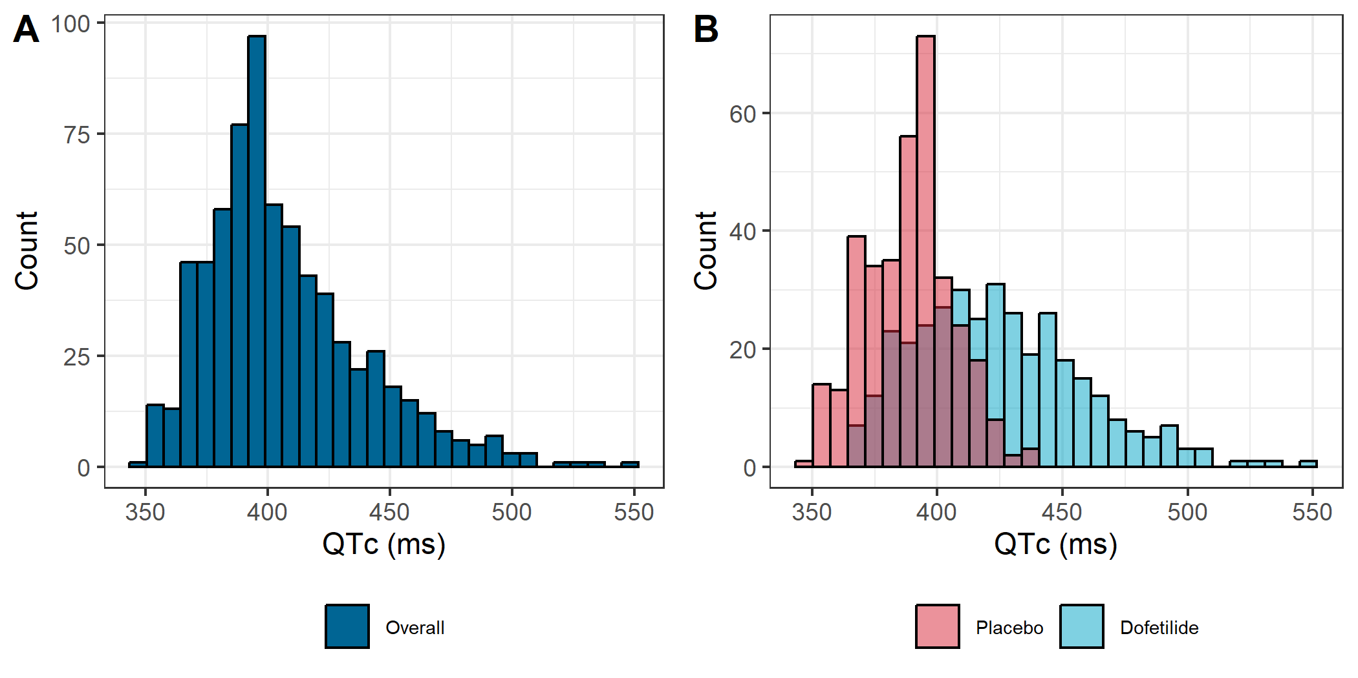
Subject-level QTc time profiles stratified by treatment are shown in Figure 3.
Figure 3: Subject-level QTc time profiles by treatment
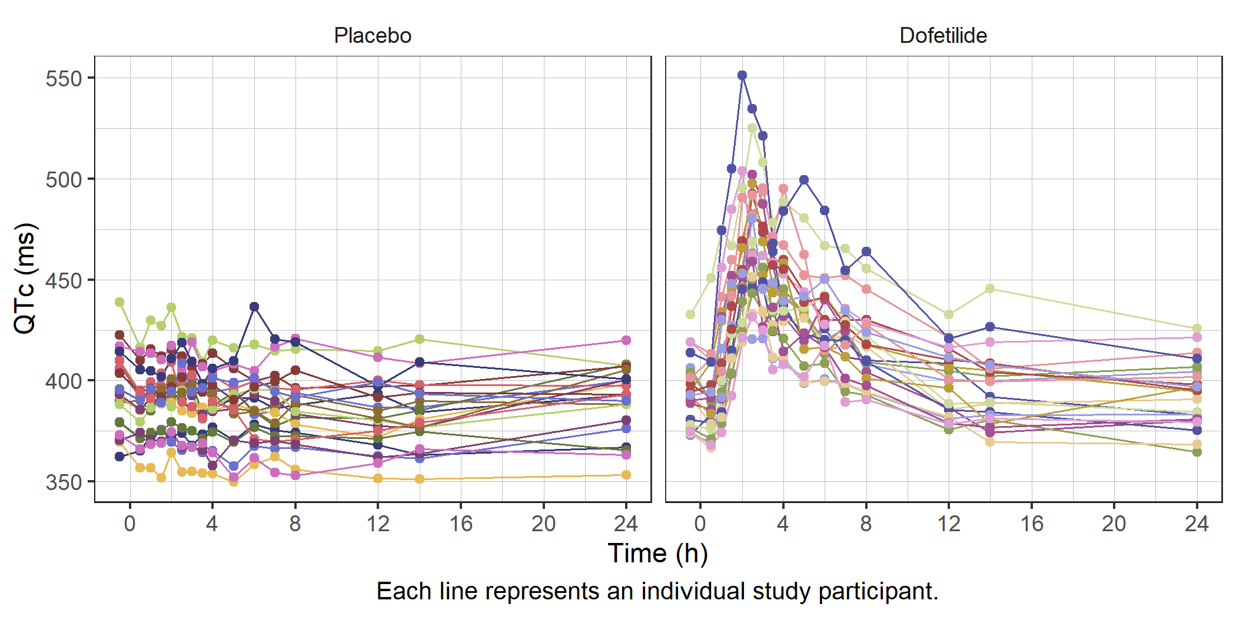
The corresponding time courses of mean QTc, stratified by treatment, are displayed in Figure 4.
Figure 4: Mean QTc vs time, by treatment.
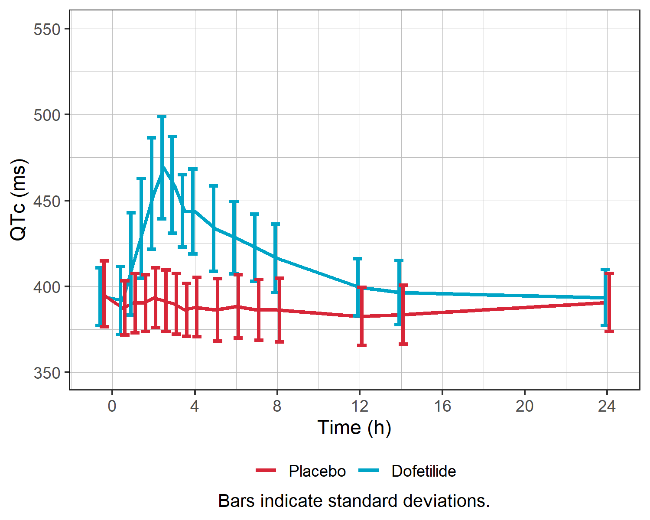

3.3 Heart rate correction analysis
QT interval duration generally increases with RR interval duration. The heart-rate corrected QT interval duration, QTc, was obtained using the Fridericia correction: QTc=QT/(RR [ms])^{1/3} [change if another method was used]. Linear regression fit slopes of QT and QTc on RR were 0.139 and 0.001, respectively (Table 3) for models with intercept and slope. Visualizations show the reduced correlation between QTc and RR compared to QT and RR, whether pooled (Figure 5) or by treatment group (Figure 6).
Treatment | Slope for QT-RR | Slope for QTc-RR (p-value)
Pooled | 0.139 | 0.001 (p = 0.878)
Placebo | 0.114 | -0.02 (p = 0.004)
Dofetilide | 0.137 | -0.005 (p = 0.673)
p-values indicate if the slope is significantly different from zero.
Table 3: Slopes of the linear regression model fits for QT and QTc on RR for each treatment.
Figure 5: QT (A) and QTc (B) interval durations vs RR.
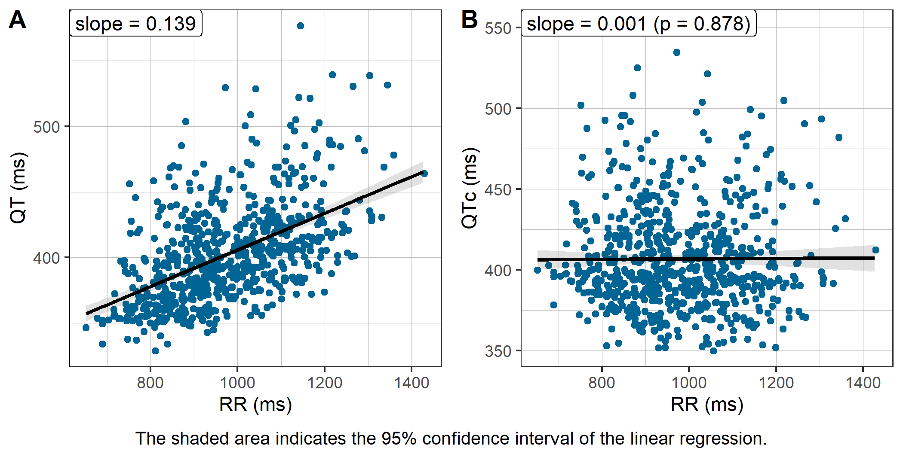
Figure 6: QT (A) and QTc (B) interval durations vs RR, by treatment.
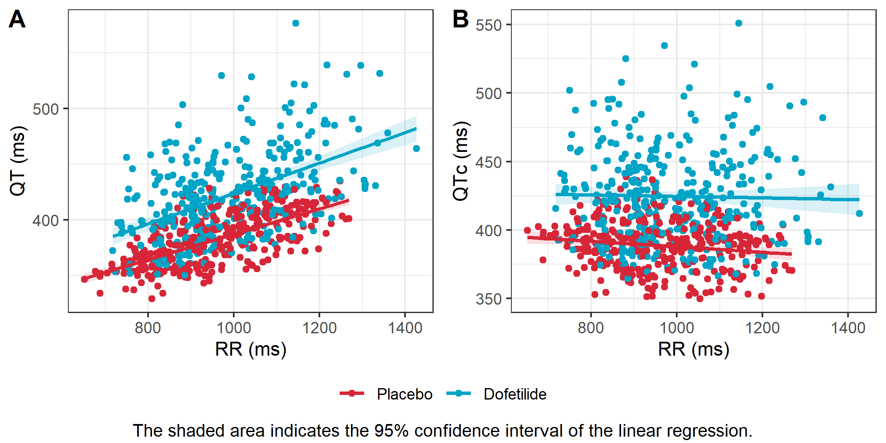

3.4 Exploratory analysis of baseline QTc
The baseline was computed as [add baseline calculation method]. Summary statistics are provided numerically (Table 4) and graphically (Figure 7).
Treatment | Baseline QTc mean | Baseline QTc range
Placebo | 395.8 | 362.4 - 438.9
Dofetilide | 394.1 | 373.0 - 432.7
Overall | 394.9 | 362.4 - 438.9
Table 4: Baseline QTc interval durations by treatment.
Figure 7: Boxplot of baseline QTc interval duration by treatment and overall.
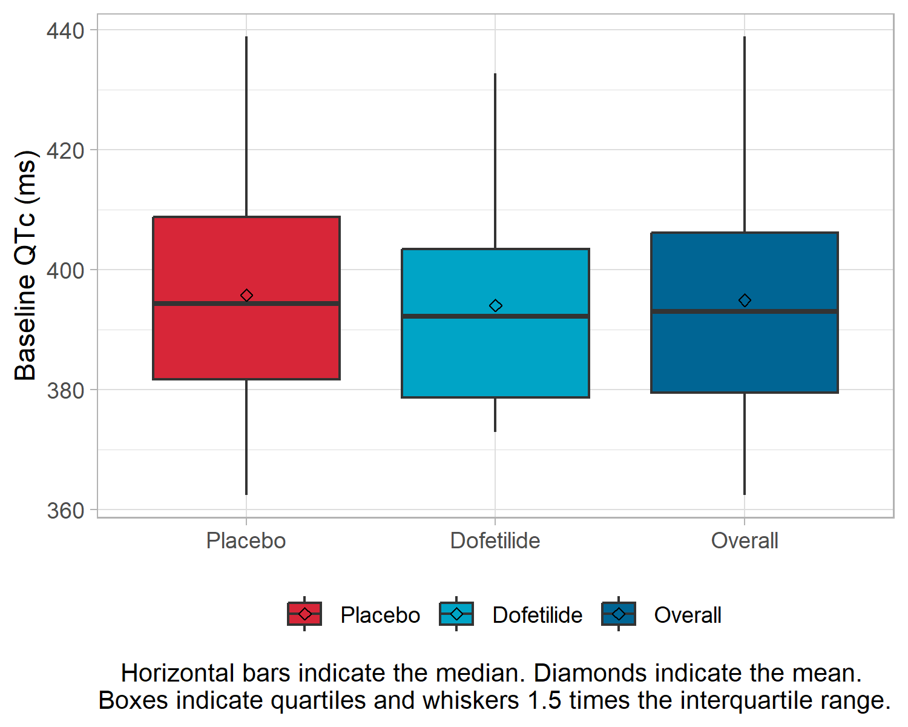

3.5 Exploratory analysis of ΔQTc
Summary statistics of ΔQTc (Table 5) and visualizations of individual and aggregate ΔQTc (Figure 8 to Figure 10) enable assessment of ΔQTc exceeding 30 ms and 60 ms, respectively. Mean ΔQTc vs concentration, colored by treatment, are shown in Figure 10.
Treatment | Range | ≤ 30 ms | > 30 and ≤ 60 ms | > 60 ms
Placebo | [-39.7, 22.1] | 352 (100%) | 0 (0%) | 0 (0%)
Dofetilide | [-16.5, 137.3] | 180 (51.1%) | 117 (33.2%) | 55 (15.6%)
Table 5: Number of ΔQTc measurements below and above thresholds values, by treatment.
Figure 8: Subject-level ΔQTc time profiles by treatment.
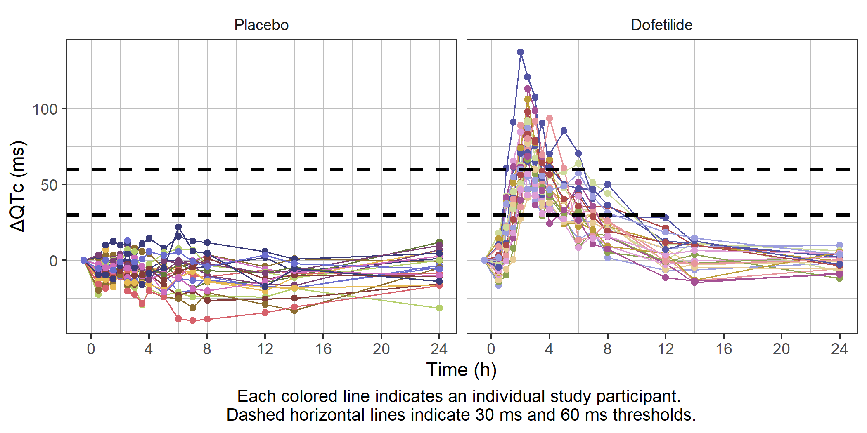
Figure 9: Mean ΔQTc vs time, by treatment.
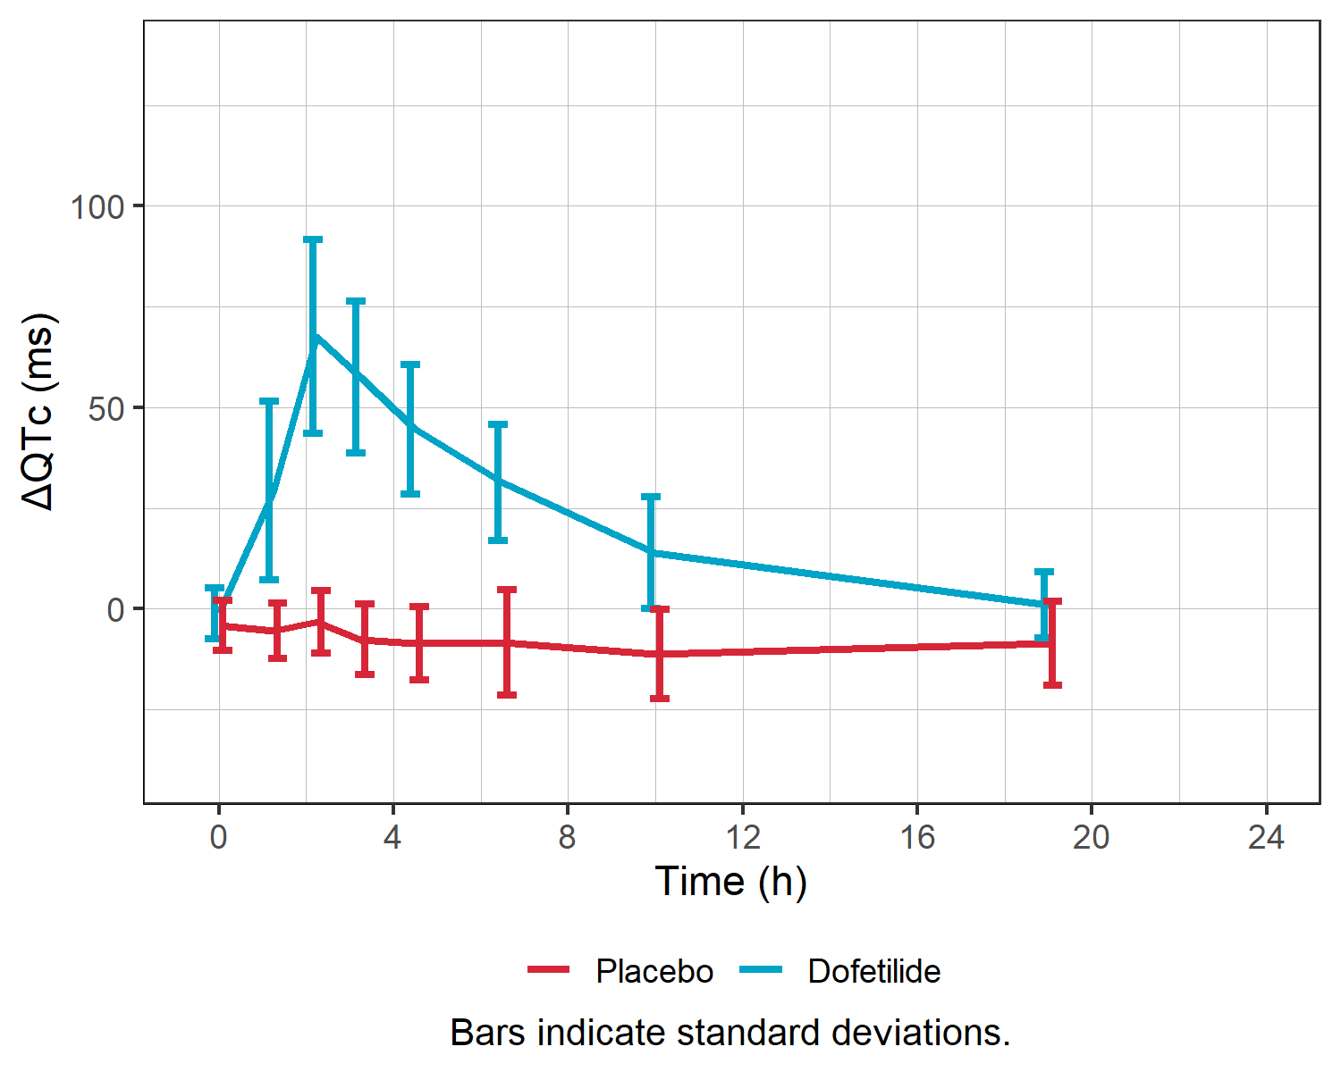
Figure 10: ΔQTc vs concentration.
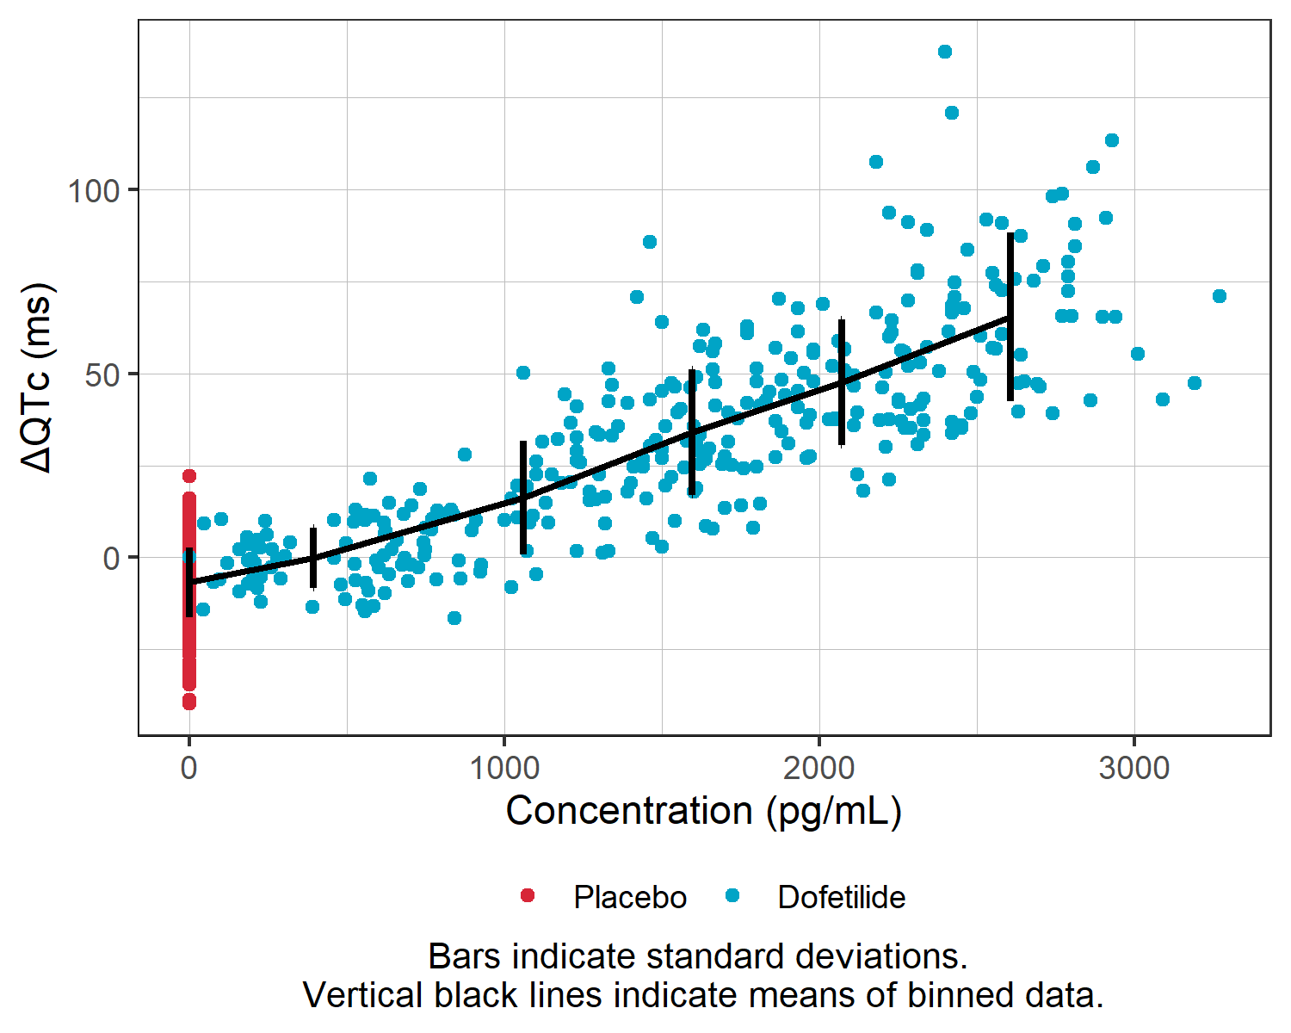

3.6 Exploratory analysis of ΔΔQTc
ΔΔQTc was not present in the dataset.

3.7 Exploratory analysis of concentration-time profiles
Individual and aggregate Dofetilide concentration vs time are visualized in the following (Figure 11, Figure 12). The mean concentration time course stratified by treatment is shown in Figure 13.
Figure 11: Subject-level concentration time profiles (linear y-axis).
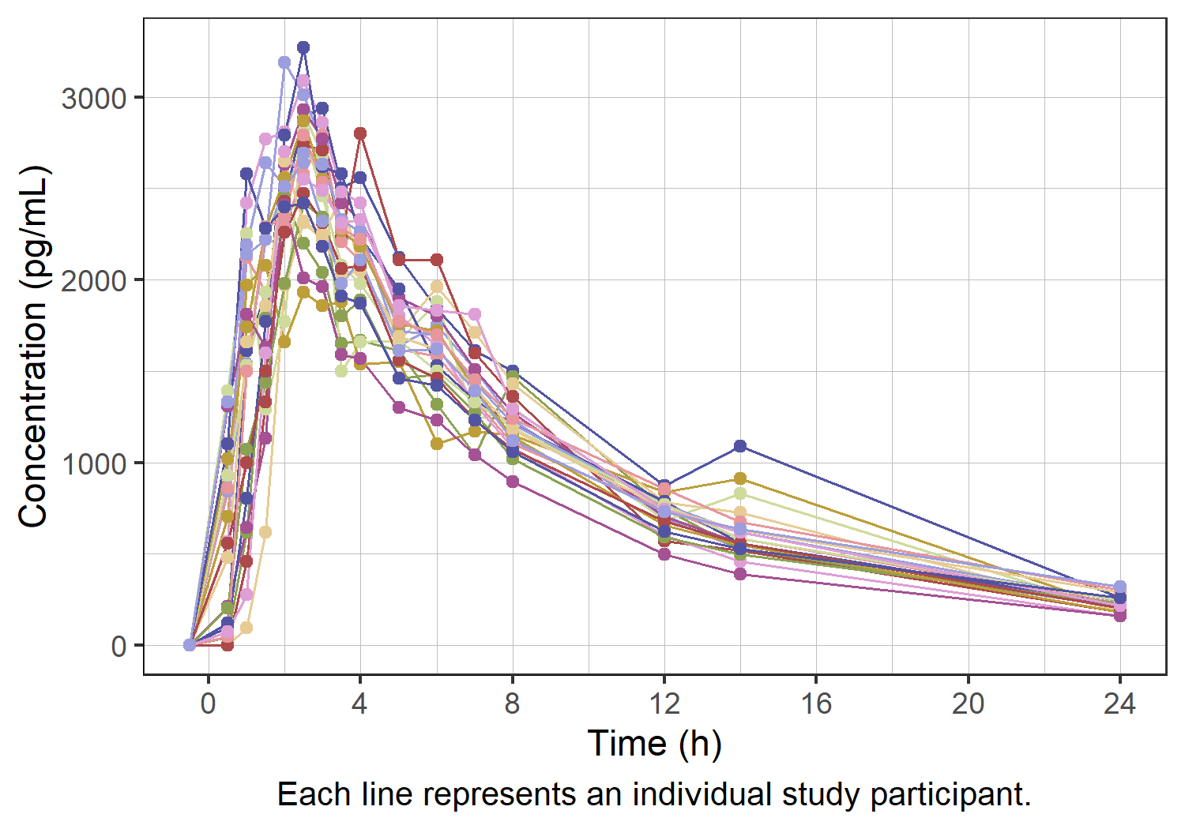
Figure 12: Subject-level concentration time profiles (logarithmic y-axis).
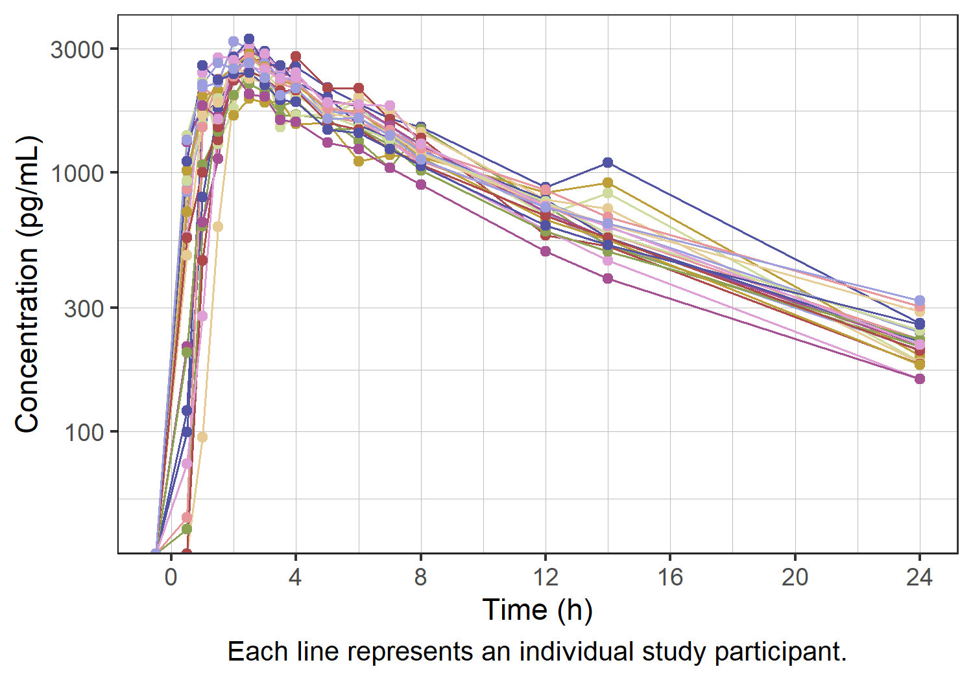
Figure 13: Mean concentration vs time , with linear (A) and logarithmic (B) y-axis.
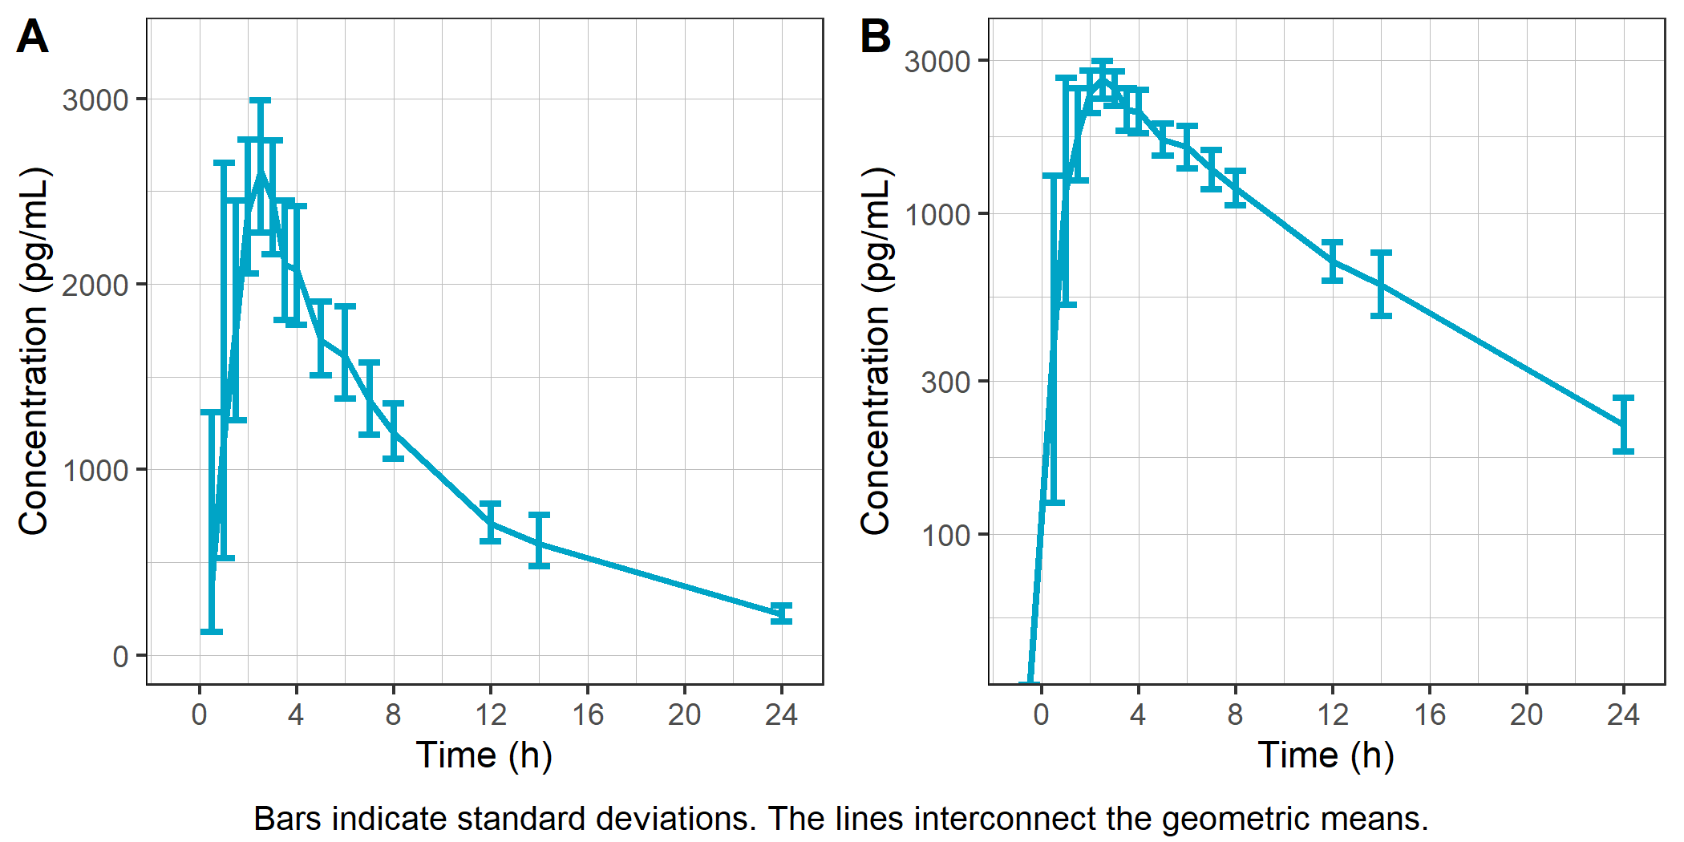

4. Assessment of model assumptions
This section evaluates assumptions made in the modeling process using the following graphics:
- Assumption 1: No drug effect on the heart rate
  - ΔHR mean and standard error vs time, stratified by treatment
- Assumption 2: QTc is independent of HR (in drug-free or placebo treatments)
  - Scatterplots of QTc vs RR interval duration for active and placebo treatment
  - QTc-RR quantile plots with linear mixed effects regression fits and 90% confidence intervals
- Assumption 3: Linear concentration-ΔQTc relationship
  - Concentration-ΔQTc scatter plot with nonlinear local smoother
- Assumption 4: No time delay between drug concentrations and ΔQTc
  - ΔQTc mean and standard deviation vs concentration by treatment, interconnected in temporal order
  - BICc criteria for direct and indirect (effect compartment) linear models

4.1 Assumption 1: No drug effect on heart rate
Figure 14 shows the time course of the mean heart rate stratified by treatment to assess a potential drug effect on heart rate. Although there is no consensus on the specific threshold effect on HR that could influence QT/ QTc assessment, mean changes of 10 bpm or more are considered problematic [9]. The change from baseline ΔHR is shown in Figure 14 with the +10 and -10 bpm thresholds.
Figure 14: Mean heart rate (A) and baseline-corrected heart rate (B) vs time.
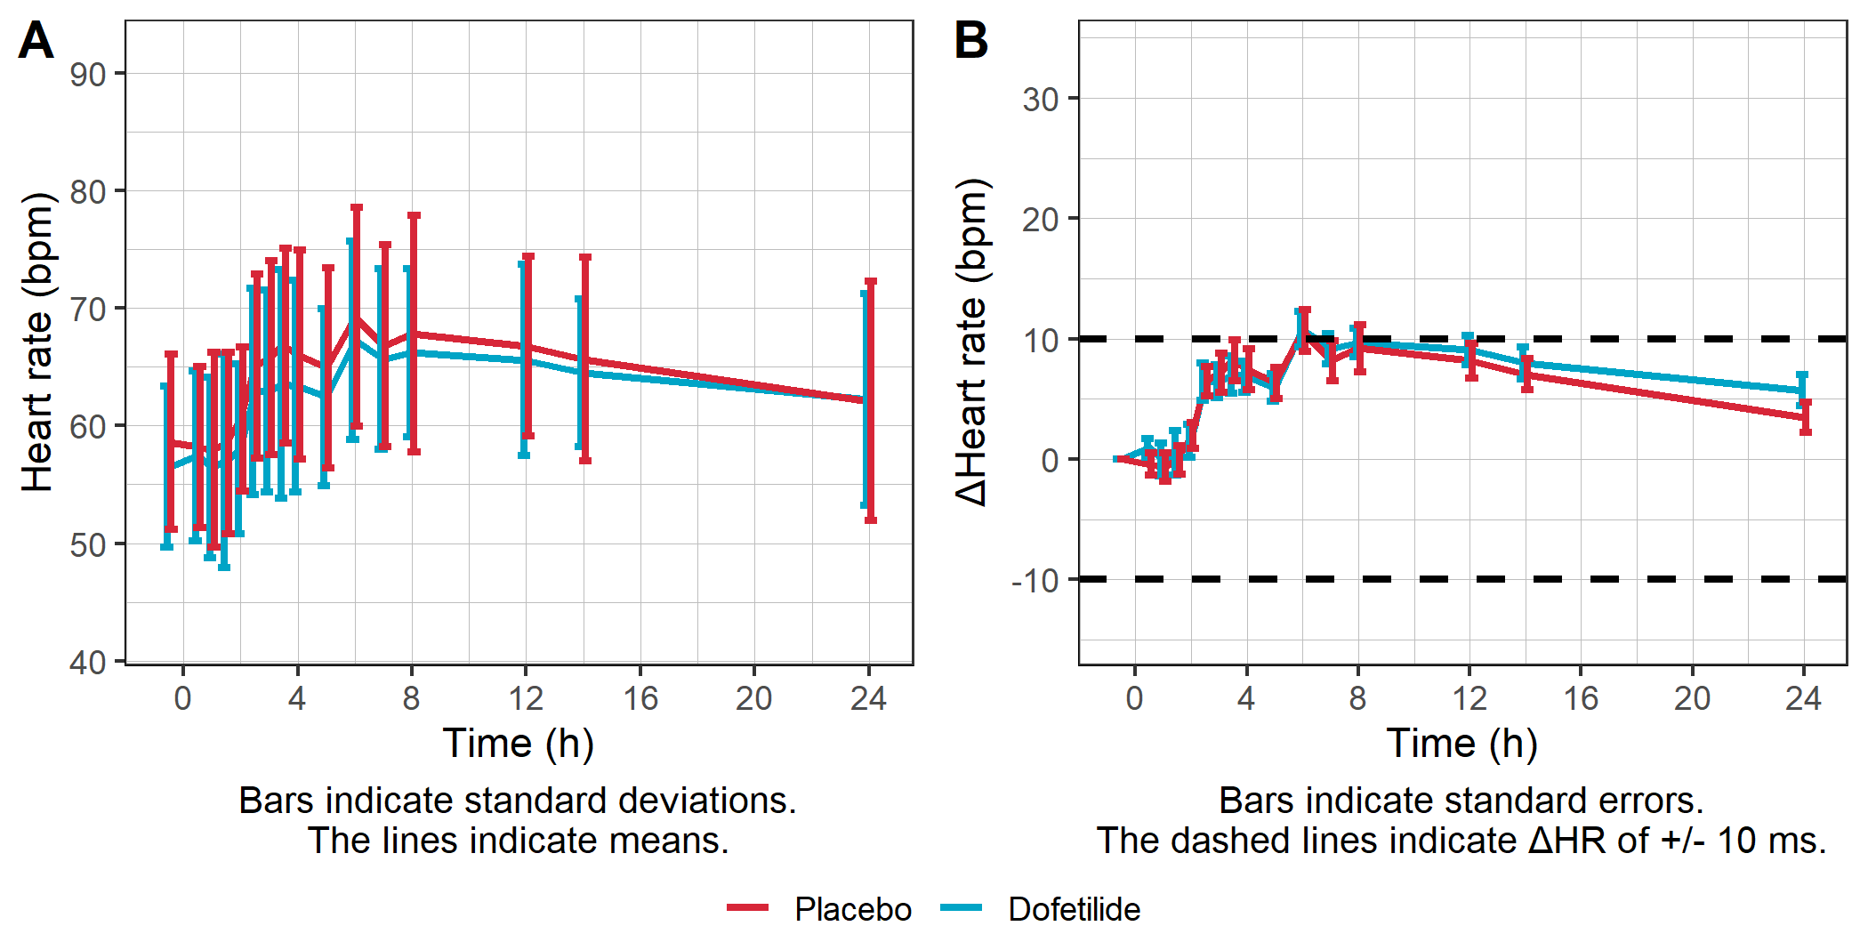

4.2 Assumption 2: QTc interval duration is independent of RR interval duration
A scatter plot of QTc interval duration vs RR interval duration, stratified by treatment, is provided in Figure 15.
Figure 15: QTc interval duration vs RR, overall (A) and by treatment (B).
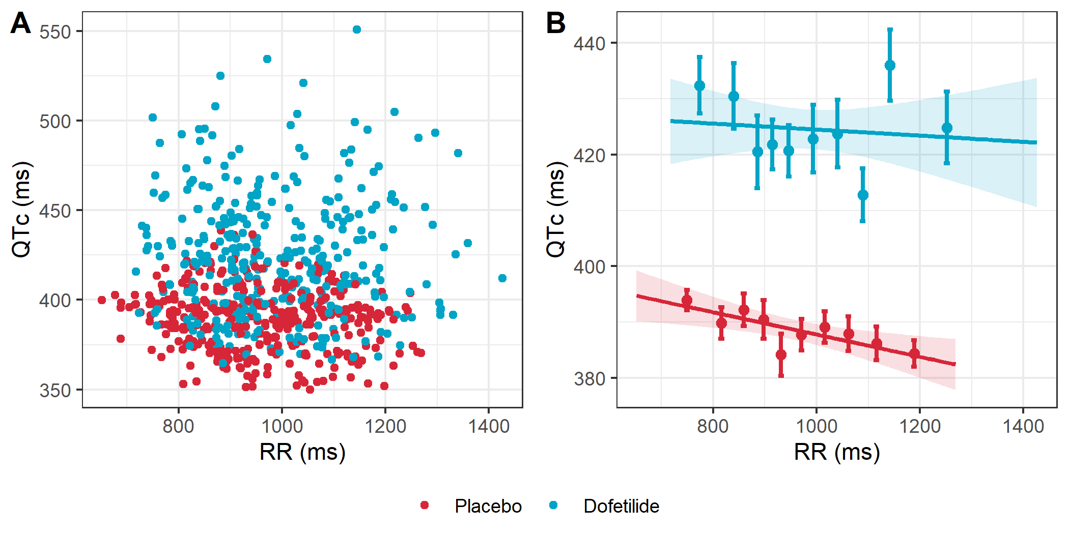
Table 6 slope estimates, confidence intervals, and p-values of the linear regression for each treatment to numerically assess the assumption.
Treatment | Slope | 90% CI | p-value | RR range (ms)
Pooled | 0.001 | [-0.013, 0.016] | 0.878 | 652 - 1426
Placebo | -0.020 | [-0.031, -0.009] | 0.004 | 652 - 1268
Dofetilide | -0.005 | [-0.026, 0.016] | 0.673 | 718 - 1426
Table 6: Slopes of the linear regression of QTc interval duration vs RR interval duration, by treatment.

4.3 Assumption 3: Linearity of the concentration-ΔQTc relationship
The linearity assumption between exposure and ΔQTc is assessed by a concentration-ΔQTc plot with linear regression (Figure 16) and LOESS smoother.
Figure 16: ΔQTc vs concentration.
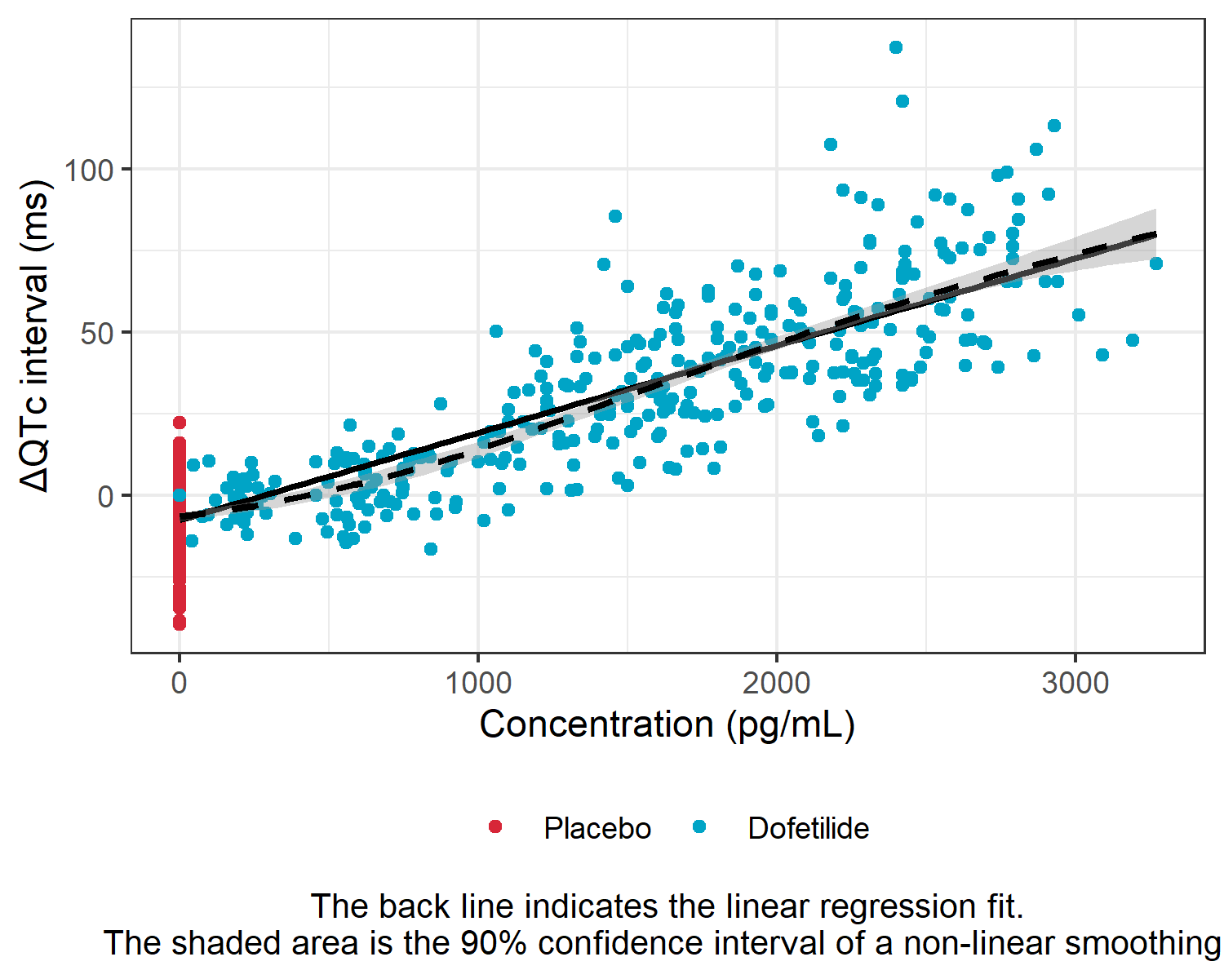

4.4 Assumption 4: No time delay between drug concentration and ΔQTc
The assumption of a direct effect, i.e., an immediate change in ΔQTc following a change in concentration, is assessed visually (Figure 17). With a direct effect, the effect increases and decreases with concentration on the same path. A counterclockwise pattern might suggest presence of hysteresis, i.e., a delayed effect.
Figure 17: Mean ΔQTc per time point vs concentration
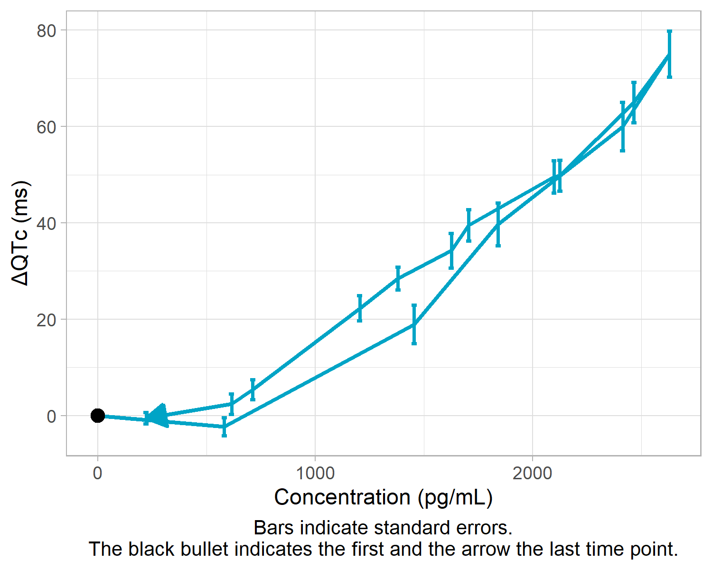
Presence or absence of hysteresis may be assessed numerically by comparing goodness of fit for a direct- and an indirect-effect model. Lower BICc values indicate better model fits.
Model type | dynamic | BICc | BICc diff.  vs direct model | tau0 (hr)
direct | ΔQTc = ΔQTc0 + slope*Cc | 5,359.7
indirect | dCe/dt = (1/tau0)*(Cc-Ce)  ΔQTc = ΔQTc0 + slope*Ce | 5,250.1 | -109.6 | 0.29
BICc: corrected Bayesian information criterion; Cc: drug concentration; Ce: hypothetical concentration in the effect compartment; tau0: time constant to the effect compartment.
Table 7: Model fit comparison between direct- and indirect-effect models.
The comparison suggests that the indirect-effect model describes the data better than the direct-effect model (ΔBICc=-109.6<0), i.e there is evidence of a delayed effect.
As there is evidence of a delayed effect, it is strongly suggested to use a popPK analysis to model the PK dynamics and link it to ΔQTc. In the following, the potential delay is ignored as it is not possible to calculate a confidence interval for ΔΔQTc using a model with effect compartment to capture the delay without a PK model.

5. Modeling results

5.1 Models tested
The tested models are compared via the BICc, which takes into account the likelihood (goodness of fit) and a penalty for the number of parameters. A lower BICc value indicates a better model. The identifiability of the parameter estimates is another important model characteristic, which is captured in the relative standard error (RSE). If the RSE cannot be computed (infinite value), the corresponding parameter estimate may be very uncertain and unidentifiable.
Structural model | BICc | BICc difference  to the linear model | Unidentifiable parameters  (Infinite RSE)
No-drug-effect model | 6,078.4 | +718.6 | No
Linear model | 5,359.7 | 0 | No
Log-linear model | 5,370.0 | +10.3 | No
Emax model | 5,377.5 | +17.7 | No
Emax model with sigmoidicity | 5,363.9 | +4.2 | No
Table 8: BICc for different structural models.
Five structural models were tested (Table 8) and assessed for a better BICc compared to the linear model. The selected model is the Linear model . This model is used in the following.

5.2 Population parameter estimation
The model parameters are estimated using the SAEM algorithm [10, 11]. A summary of the parameter values, standard errors and 95% confidence intervals is provided in Table 9.
Population Parameter | Estimate | SE | RSE (%) | 95% CI
Intercept | -0.0922 | 1.882 | 2042.5 | (-3.78, 3.6)
Slope | 0.02601 | 0.001491 | 5.7 | (0.0231, 0.0289)
Change from baseline effect | -0.2551 | 0.0556 | 21.8 | (-0.364, -0.146)
Treatment Effect | 0.001628 | 1.315 | 80760.7 | (-2.58, 2.58)
Effect at 0.5 h | -13.292 | 1.961 | 14.8 | (-17.14, -9.45)
Effect at 1 h | -12.887 | 2.031 | 15.8 | (-16.87, -8.91)
Effect at 1.5 h | -6.86 | 2.074 | 30.2 | (-10.92, -2.8)
Effect at 2 h | -2.201 | 2.158 | 98 | (-6.43, 2.03)
Effect at 2.5 h | 1.356 | 2.194 | 161.8 | (-2.94, 5.66)
Effect at 3 h | -2.32 | 2.166 | 93.4 | (-6.57, 1.93)
Effect at 3.5 h | -7.125 | 2.111 | 29.6 | (-11.26, -2.99)
Effect at 4 h | -6.152 | 2.107 | 34.2 | (-10.28, -2.02)
Effect at 5 h | -6.972 | 2.054 | 29.5 | (-11, -2.95)
Effect at 6 h | -7.619 | 2.045 | 26.8 | (-11.63, -3.61)
Effect at 7 h | -8.203 | 2.018 | 24.6 | (-12.16, -4.25)
Effect at 8 h | -9.121 | 2.001 | 21.9 | (-13.04, -5.2)
Effect at 12 h | -13.041 | 1.965 | 15.1 | (-16.89, -9.19)
Effect at 14 h | -12.851 | 1.961 | 15.3 | (-16.69, -9.01)
Effect at 24 h | -5.692 | 1.948 | 34.2 | (-9.51, -1.88)
IIV intercept (SD) | 5.178 | 0.898 | 17.3 | (3.71, 7.22)
IIV slope (SD) | 0.00596 | 0.000971 | 16.3 | (0.00435, 0.0082)
Residual error (SD) | 9.126 | 0.2511 | 2.8 | (8.65, 9.63)
SE: standard error; RSE: relative standard error; CI: confidence interval; IIV: inter-individual variability.
Table 9: Estimated population parameters.

5.3 Goodness of fits
Goodness-of-fit (GOF) plots shown in the following include observed vs predicted ΔQTc (Figure 18), visual predictive checks of ΔQTc vs time and vs concentration (Figure 19), and analysis of residuals (Figure 20 to Figure 22).
Figure 18: Observed vs individual predicted ΔQTc.
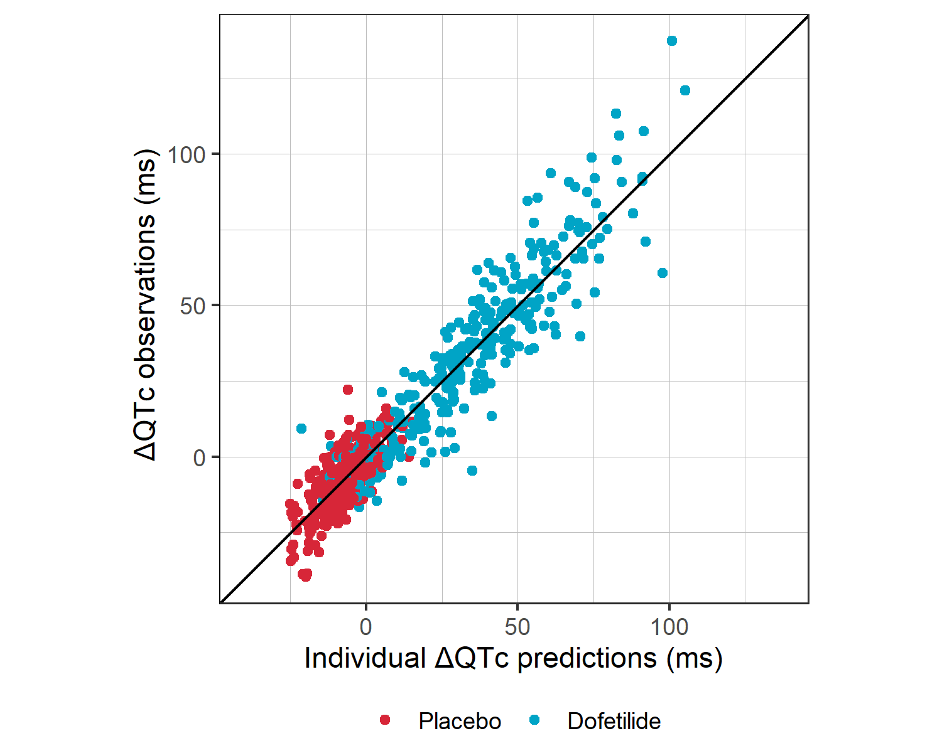
Figure 19: Visual predictive checks for ΔQTc vs time (A) and vs concentration (B).
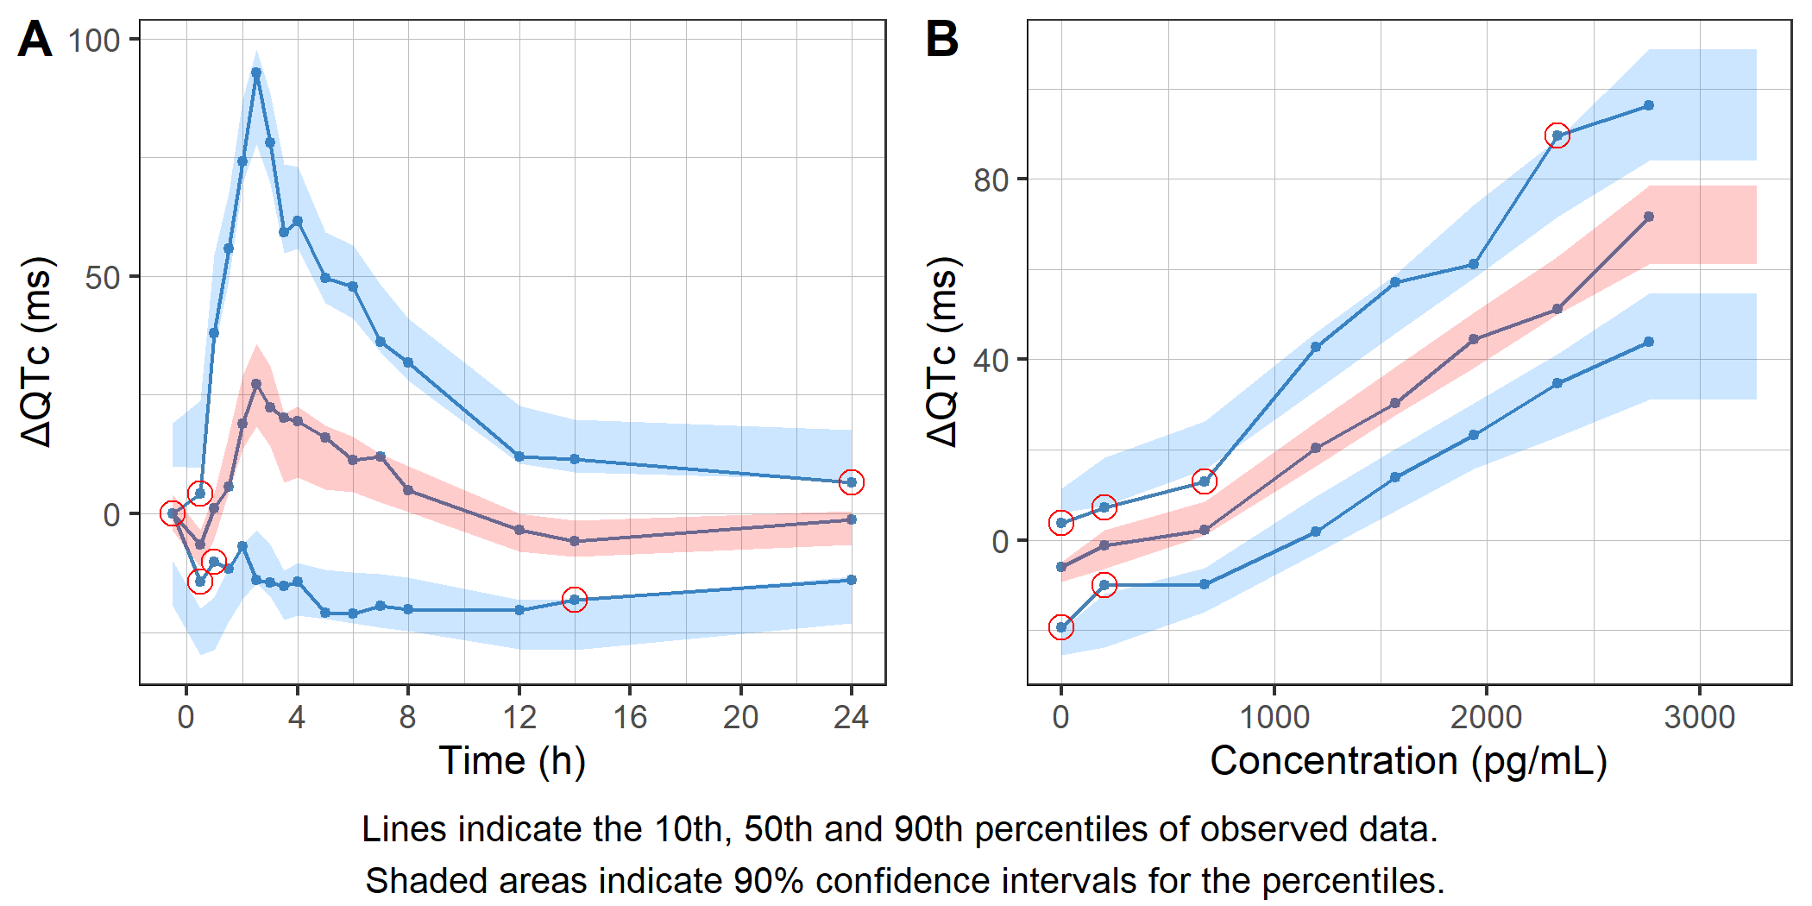
Figure 20: Distribution of individual residuals as histogram (A) and quantile-quantile plot (B).
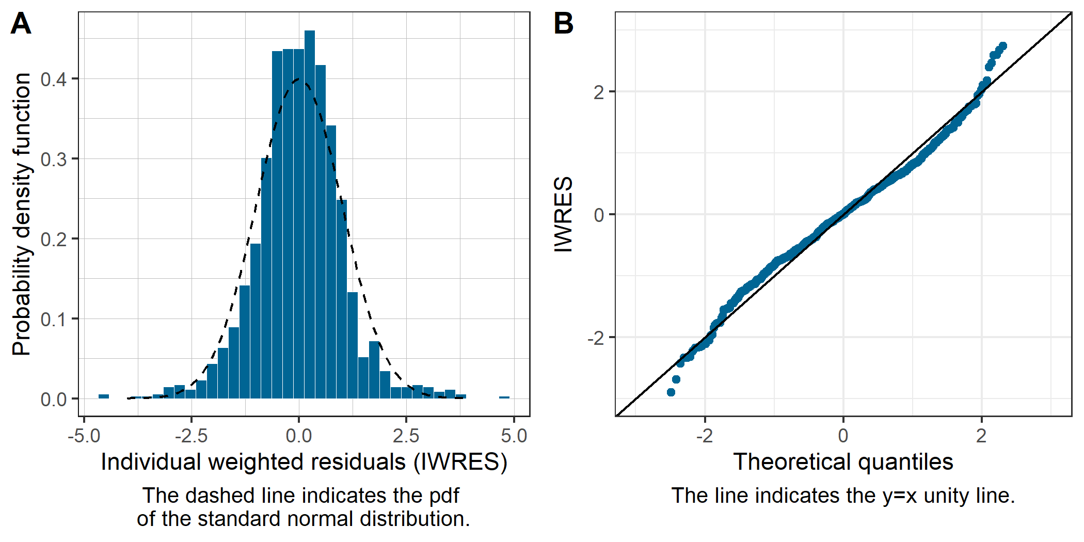
Residuals vs time and vs predictions are shown in Figure 21.
Figure 21: Individual weighted residuals (IWRES) vs time (A) and vs individual ΔQTc predictions (B).
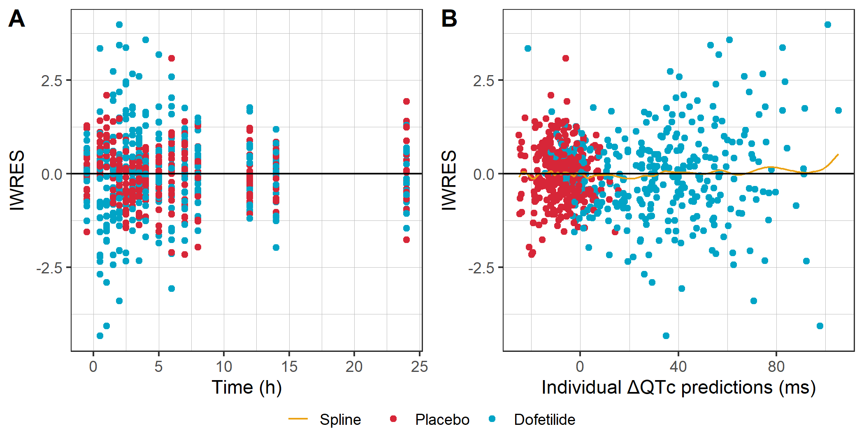
Figure 22: Individual weighted residuals (IWRES) vs drug concentration (A) and vs centered QTc baseline (B).
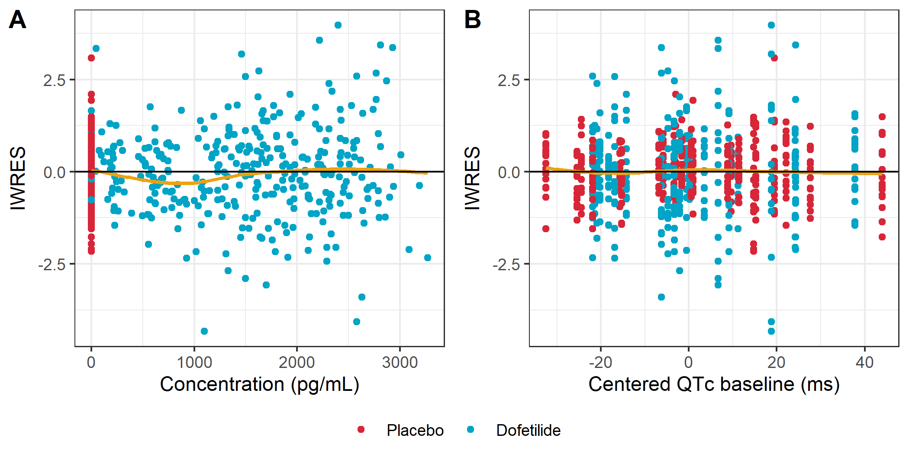

6. Model predictions

6.1 Evaluation of the final model
Model adequacy is assessed in Figure 23 showing the ΔQTc model prediction and its corresponding 90% confidence interval. The overlay of empirical means and standard errors for 10 approximately equally-sized bins support assessment of the adequacy of the model fit. The model prediction takes into account the intercept, concentration effect and treatment effect, while time factors and the centered baseline covariate effects are ignored (i.e set to zero). The observed ΔQTc data was adjusted by the estimated time effect for each time point in order to be comparable to the model prediction.. The 90% confidence interval is derived using 500 samples from the estimated parameter uncertainty distribution (i.e the Fisher information matrix).
Figure 23: ΔQTc predictions vs drug concentration.
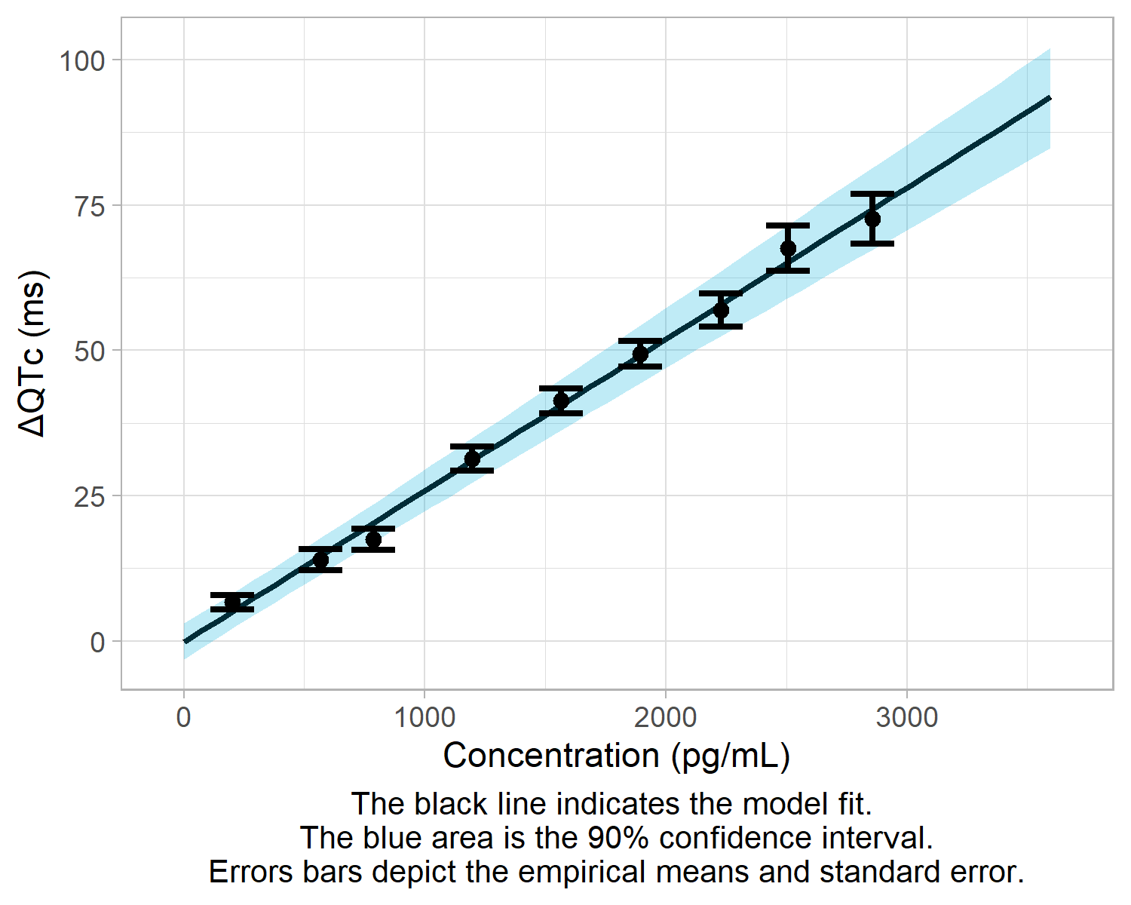

6.2 Model-derived ΔΔQTc at concentrations of interest
The concentration at which the two-sided 90% confidence interval of the relation between model-derived ΔΔQTc and drug concentration reaches 10 ms serves as a basis for the QT liability assessment. Model-derived ΔΔQTc is obtained as ΔΔQTc = ΔQTc(treatment, conc) - ΔQTc(placebo, conc=0). The intercept, time-effects and centered baseline cancel out, while the treatment effect and concentration effect remain [3].
Figure 24: Two-sided 90% CI of ΔΔQTc prediction.
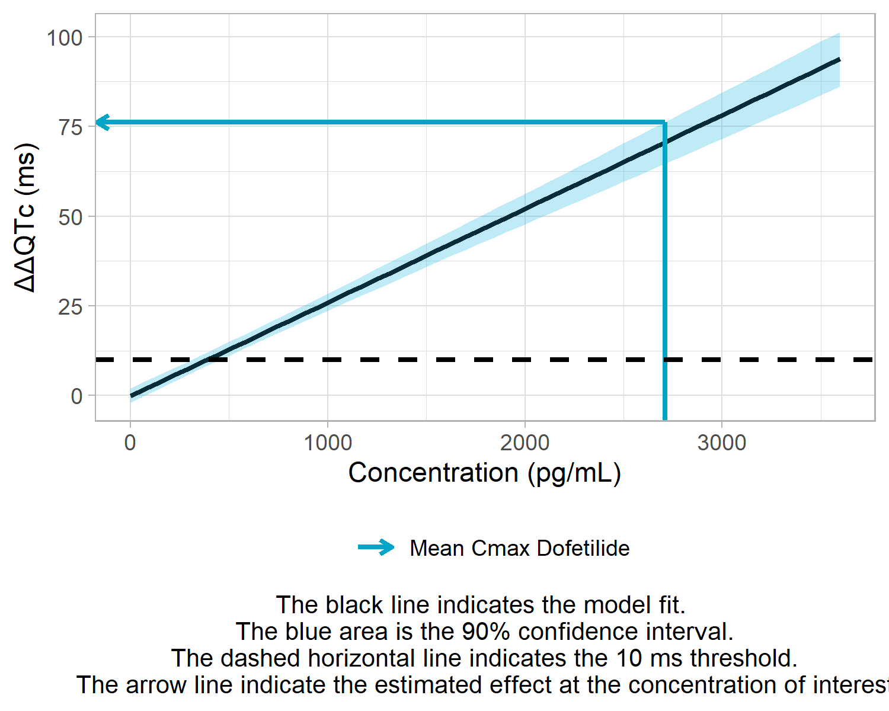
Treatment | Geometric mean Cmax  (pg/mL) | Upper limit of 90% CI  for ΔΔQTc (ms)
Dofetilide | 2,709.9 | 76.2
Table 10: Upper limit of the two-sided 90% CI of ΔΔQTc prediction by treatment at geometric mean maximum concentration.
The two-sided 90% confidence interval at the geometric mean maximum concentration exceeds the 10 ms threshold (Figure 24 and Table 10). The concentration at which the upper limit of the two-sided 90% confidence interval reaches 10 ms is estimated to be 310.9 pg/mL.

7. Appendix

7.1 Parameter estimates for all models
The summary of the parameter values and relative standard errors for all tested models is provided in Table 11.
Parameter | No-drug-effect model | Linear model | Log-linear model | Emax model | Emax model with sigmoidicity
BICc | 6078.4 | 5359.7 | 5370 | 5377.5 | 5363.9
Intercept | -18.98  (15.2%) | -0.09  (2042.5%) | 0.44  (431%) | 1.25  (153.1%) | 0.01  (32579.3%)
Slope |  | 0.03  (5.7%)
Maximum effect |  |  |  | 442.82  (20.7%) | 382.43  (23.4%)
Concentration of 50% of max effect |  |  |  | 14089.47  (24.9%) | 8201.57  (26.5%)
Hill coefficient |  |  |  |  | 1.34  (7.1%)
p1 |  |  | 455.74  (23%)
p2 |  |  | 15846.68  (25.2%)
Change from baseline effect | -0.27  (27.2%) | -0.26  (21.8%) | -0.27  (20.9%) | -0.27  (20.9%) | -0.31  (18.4%)
Treatment Effect | 37.18  (3.3%) | 0  (80760.7%) | -1.94  (70%) | -2.7  (53.6%) | 2.24  (76.1%)
Time 0.5 h | -5.37  (63.8%) | -13.29  (14.8%) | -13.85  (14.2%) | -14.26  (14%) | -12.18  (16.5%)
Time 1 h | 6.75  (50.8%) | -12.89  (15.8%) | -13.78  (14.8%) | -14.18  (14.6%) | -11.95  (17.6%)
Time 1.5 h | 17.12  (20%) | -6.86  (30.2%) | -7.88  (26.5%) | -8.27  (25.6%) | -6.04  (35.6%)
Time 2 h | 28.83  (11.9%) | -2.2  (98%) | -3.12  (69.4%) | -3.15  (69.5%) | -2.16  (100.4%)
Time 2.5 h | 35.46  (9.7%) | 1.36  (161.8%) | 0.64  (345%) | 0.86  (256.9%) | 1.21  (179.4%)
Time 3 h | 29.55  (11.6%) | -2.32  (93.4%) | -3.23  (67.3%) | -3.19  (68.7%) | -2.34  (92.5%)
Time 3.5 h | 20.16  (17%) | -7.12  (29.6%) | -8.14  (26.1%) | -8.45  (25.5%) | -6.63  (32.6%)
Time 4 h | 20.87  (16.4%) | -6.15  (34.2%) | -7.17  (29.5%) | -7.5  (28.7%) | -5.61  (38.5%)
Time 5 h | 15.04  (22.8%) | -6.97  (29.5%) | -8.08  (25.6%) | -8.66  (24.4%) | -5.87  (37%)
Time 6 h | 13.4  (25.6%) | -7.62  (26.8%) | -8.73  (23.6%) | -9.32  (22.5%) | -6.42  (33.8%)
Time 7 h | 9.54  (36%) | -8.2  (24.6%) | -9.28  (21.9%) | -9.96  (20.8%) | -6.69  (32.5%)
Time 8 h | 6.4  (53.6%) | -9.12  (21.9%) | -10.15  (19.9%) | -10.84  (19%) | -7.42  (29.2%)
Time 12 h | -3.94  (87%) | -13.04  (15.1%) | -13.79  (14.3%) | -14.38  (14%) | -11.18  (18.7%)
Time 14 h | -4.96  (69.1%) | -12.85  (15.3%) | -13.52  (14.6%) | -14.05  (14.2%) | -11.09  (18.6%)
Time 24 h | -2.93  (117.2%) | -5.69  (34.2%) | -5.97  (32.7%) | -6.19  (31.8%) | -4.78  (40.9%)
IIV intercept (SD) | 6.73  (17.8%) | 5.18  (17.3%) | 5.24  (17.3%) | 5.22  (17.4%) | 5.75  (16.8%)
IIV slope (SD) |  | 0.01  (16.3%)
IIV Emax (SD) |  |  |  | 96.05  (16.3%) | 91.42  (16.3%)
IIV p1 (SD) |  |  | 102.03  (16.3%)
Residual error (SD) | 16.08  (2.7%) | 9.13  (2.8%) | 9.14  (2.8%) | 9.19  (2.8%) | 9.03  (2.8%)
Parameter estimates are shown with their relative standard errors in parentheses.
Table 11: Estimated population parameters and relative standard errors for all models

7.2 Model fits for all models
The ΔQTc prediction for each structural model is presented in Figure 25.
Figure 25: Predicted ΔQTc vs concentration for each model.
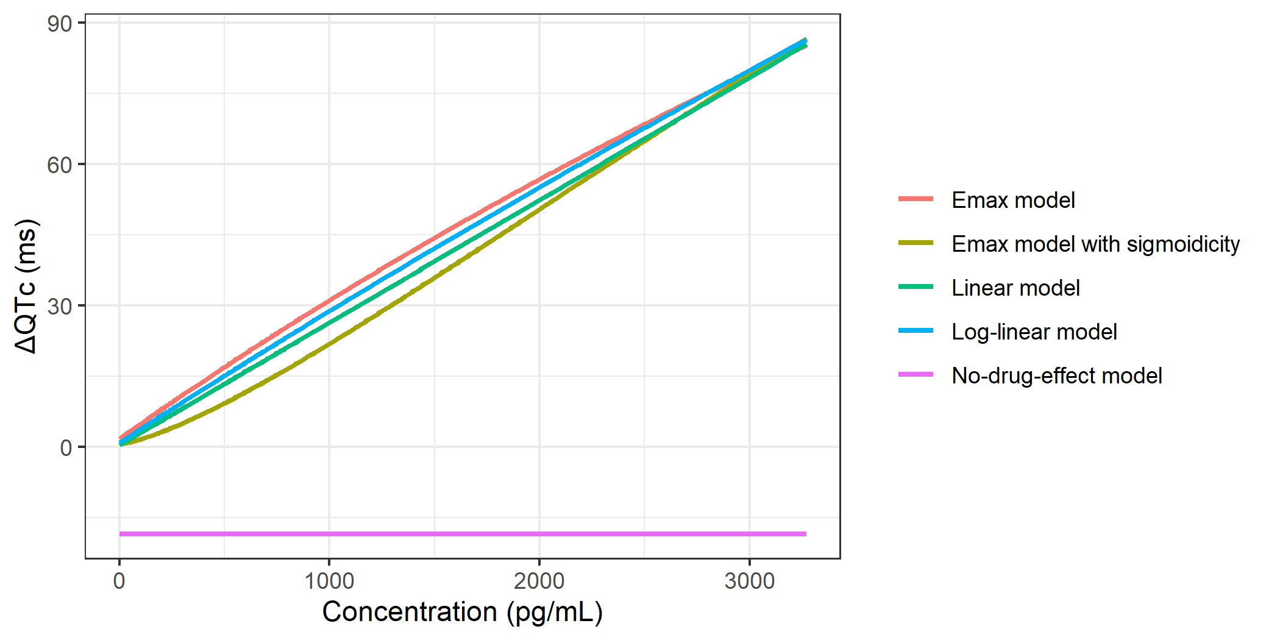

7.3 Monolix input and output files

7.3.1 Mlxtran file
The content of the Monolix mlxtran file for the best model is shown below.
<DATAFILE>
[FILEINFO]
file={path='dQTc_Linear_data.csv'}
delimiter = comma
header={RANDID, SEX, AGE, HGHT, WGHT, SYSBP, DIABP, RACE, ETHNIC, VISIT, EXTRT, EXDOSE, EXDOSU, TPT, BASELINE, PCTEST, PCSTRESU, RR, PR, QRS, BLQTc, BLHR, BLQTc_cent, BLQTc_centAdjPl, ddQTc, ddHR, Cc_reg, RR_reg, TIME_cat, EXTRT_OCC, TIME_cat_OCC, OBS, OBSID}
[CONTENT]
RANDID = {use=identifier}
EXTRT = {use=covariate, type=categorical}
TPT = {use=time}
BLQTc_cent = {use=covariate, type=continuous}
Cc_reg = {use=regressor}
RR_reg = {use=regressor}
TIME_cat = {use=covariate, type=categorical}
EXTRT_OCC = {use=occasion}
TIME_cat_OCC = {use=occasion}
OBS = {use=observation, yname={'CONC', 'HR', 'QT', 'QTc', 'dHR', 'dQTc'}, type={continuous, continuous, continuous, continuous, continuous, continuous}}
OBSID = {use=observationtype}
[SETTINGS]
regressorType = linearInterpolation
<MODEL>
[COVARIATE]
input = {BLQTc_cent, EXTRT, TIME_cat}
EXTRT = {type=categorical, categories={'Dofetilide', 'Placebo'}}
TIME_cat = {type=categorical, categories={'-0.5', '0.5', '1', '1.5', '12', '14', '2', '2.5', '24', '3', '3.5', '4', '5', '6', '7', '8'}}
DEFINITION:
tTRT =
{
transform = EXTRT,
categories = {
'placebo' = {'Placebo'},
'active' = {'Dofetilide'} },
reference = 'placebo'
}
[INDIVIDUAL]
input = {dQTc0_pop, eta_dQTc0_pop, omega_eta_dQTc0, slope_pop, omega_slope, BLQTc_cent, beta_dQTc0_BLQTc_cent, TIME_cat, beta_dQTc0_TIME_cat_0_5, beta_dQTc0_TIME_cat_1, beta_dQTc0_TIME_cat_1_5, beta_dQTc0_TIME_cat_12, beta_dQTc0_TIME_cat_14, beta_dQTc0_TIME_cat_2, beta_dQTc0_TIME_cat_2_5, beta_dQTc0_TIME_cat_24, beta_dQTc0_TIME_cat_3, beta_dQTc0_TIME_cat_3_5, beta_dQTc0_TIME_cat_4, beta_dQTc0_TIME_cat_5, beta_dQTc0_TIME_cat_6, beta_dQTc0_TIME_cat_7, beta_dQTc0_TIME_cat_8, tTRT, beta_dQTc0_tTRT_active}
TIME_cat = {type=categorical, categories={'-0.5', '0.5', '1', '1.5', '12', '14', '2', '2.5', '24', '3', '3.5', '4', '5', '6', '7', '8'}}
tTRT = {type=categorical, categories={'placebo', 'active'}}
DEFINITION:
dQTc0 = {distribution=normal, typical=dQTc0_pop, covariate={BLQTc_cent, TIME_cat, tTRT}, coefficient={beta_dQTc0_BLQTc_cent, {0, beta_dQTc0_TIME_cat_0_5, beta_dQTc0_TIME_cat_1, beta_dQTc0_TIME_cat_1_5, beta_dQTc0_TIME_cat_12, beta_dQTc0_TIME_cat_14, beta_dQTc0_TIME_cat_2, beta_dQTc0_TIME_cat_2_5, beta_dQTc0_TIME_cat_24, beta_dQTc0_TIME_cat_3, beta_dQTc0_TIME_cat_3_5, beta_dQTc0_TIME_cat_4, beta_dQTc0_TIME_cat_5, beta_dQTc0_TIME_cat_6, beta_dQTc0_TIME_cat_7, beta_dQTc0_TIME_cat_8}, {0, beta_dQTc0_tTRT_active}}, no-variability}
eta_dQTc0 = {distribution=normal, typical=eta_dQTc0_pop, sd=omega_eta_dQTc0}
slope = {distribution=normal, typical=slope_pop, sd=omega_slope}
[LONGITUDINAL]
input = {adQTc}
file = 'model_dQTc_Linear.txt'
DEFINITION:
deltaQTc = {distribution=normal, prediction=dQTc, errorModel=constant(adQTc)}
<FIT>
data = 'dQTc'
model = deltaQTc
<PARAMETER>
adQTc = {value=12.4516249171882, method=MLE}
beta_dQTc0_BLQTc_cent = {value=-0.0950204136706201, method=MLE}
beta_dQTc0_TIME_cat_0_5 = {value=-12.7797300793203, method=MLE}
beta_dQTc0_TIME_cat_1 = {value=-11.987221460923, method=MLE}
beta_dQTc0_TIME_cat_12 = {value=-13.0183230482336, method=MLE}
beta_dQTc0_TIME_cat_14 = {value=-12.7980765567102, method=MLE}
beta_dQTc0_TIME_cat_1_5 = {value=-6.57138386311411, method=MLE}
beta_dQTc0_TIME_cat_2 = {value=-2.22415137733091, method=MLE}
beta_dQTc0_TIME_cat_24 = {value=-5.66017118913976, method=MLE}
beta_dQTc0_TIME_cat_2_5 = {value=1.63392309759031, method=MLE}
beta_dQTc0_TIME_cat_3 = {value=-2.16363069794328, method=MLE}
beta_dQTc0_TIME_cat_3_5 = {value=-7.16224019508561, method=MLE}
beta_dQTc0_TIME_cat_4 = {value=-6.11358829922825, method=MLE}
beta_dQTc0_TIME_cat_5 = {value=-6.89533211212182, method=MLE}
beta_dQTc0_TIME_cat_6 = {value=-7.52350311600049, method=MLE}
beta_dQTc0_TIME_cat_7 = {value=-8.22954319084824, method=MLE}
beta_dQTc0_TIME_cat_8 = {value=-9.117378585594141, method=MLE}
beta_dQTc0_tTRT_active = {value=0.318076375471473, method=MLE}
dQTc0_pop = {value=-0.159040347290556, method=MLE}
eta_dQTc0_pop = {value=0, method=FIXED}
omega_eta_dQTc0 = {value=55.6722243732658, method=MLE}
omega_slope = {value=0.027503497902417, method=MLE}
slope_pop = {value=0.025742557616765, method=MLE}
<MONOLIX>
[TASKS]
populationParameters()
individualParameters(method = {conditionalMean, conditionalMode })
fim(method = Linearization)
logLikelihood(method = Linearization)
[PLOTS]
run = true
plots = {indfits = {selected = true}, parameterdistribution = {selected = true}, obspred = {selected = true}, covariancemodeldiagnosis = {selected = true}, covariatemodeldiagnosis = {selected = true}, vpc = {selected = true}, residualsscatter = {selected = true}, residualsdistribution = {selected = true}, randomeffects = {selected = true}, saemresults = {selected = true}}
[SETTINGS]
GLOBAL:
exportpath = 'dQTc_Linear'
dataandmodelnexttoproject = yes
POPULATION:
optimizationiterations = 15
optimizationtolerance = 0.001
INDIVIDUAL:
enablemaxiterations = yes

7.3.2 Structural model
The content of the structural model file for the best model is shown below.
[LONGITUDINAL]
input = {Cc, dQTc0, eta_dQTc0, slope}
Cc = {use=regressor}
EQUATION:
dQTc = dQTc0 + eta_dQTc0 + slope*Cc
OUTPUT:
output = dQTc

7.3.3 Summary output file
The main run output (summary.txt file) for the best model is shown below.
********************************************************************************
* dQTc_Linear.mlxtran *
* at *
* Monolix version : 2024R1 *
********************************************************************************
ESTIMATION OF THE POPULATION PARAMETERS ________________________________________
Fixed Effects ---------------------------- se_lin rse(%) P2.5_lin P97.5_lin
dQTc0_pop : -0.0922 1.88 2.04e+03 -3.78 3.6
beta_dQTc0_BLQTc_cent : -0.255 0.0556 21.8 -0.364 -0.146
beta_dQTc0_TIME_cat_0_5 : -13.3 1.96 14.8 -17.1 -9.45
beta_dQTc0_TIME_cat_1 : -12.9 2.03 15.8 -16.9 -8.91
beta_dQTc0_TIME_cat_1_5 : -6.86 2.07 30.2 -10.9 -2.8
beta_dQTc0_TIME_cat_12 : -13 1.97 15.1 -16.9 -9.19
beta_dQTc0_TIME_cat_14 : -12.9 1.96 15.3 -16.7 -9.01
beta_dQTc0_TIME_cat_2 : -2.2 2.16 98 -6.43 2.03
beta_dQTc0_TIME_cat_2_5 : 1.36 2.19 162 -2.94 5.66
beta_dQTc0_TIME_cat_24 : -5.69 1.95 34.2 -9.51 -1.88
beta_dQTc0_TIME_cat_3 : -2.32 2.17 93.4 -6.57 1.93
beta_dQTc0_TIME_cat_3_5 : -7.12 2.11 29.6 -11.3 -2.99
beta_dQTc0_TIME_cat_4 : -6.15 2.11 34.2 -10.3 -2.02
beta_dQTc0_TIME_cat_5 : -6.97 2.05 29.5 -11 -2.95
beta_dQTc0_TIME_cat_6 : -7.62 2.04 26.8 -11.6 -3.61
beta_dQTc0_TIME_cat_7 : -8.2 2.02 24.6 -12.2 -4.25
beta_dQTc0_TIME_cat_8 : -9.12 2 21.9 -13 -5.2
beta_dQTc0_tTRT_active : 0.00163 1.31 8.08e+04 -2.58 2.58
eta_dQTc0_pop : 0
slope_pop : 0.026 0.00149 5.73 0.0231 0.0289
Standard Deviation of the Random Effects -
omega_eta_dQTc0 : 5.18 0.898 17.3 3.71 7.22
omega_slope : 0.00596 0.000971 16.3 0.00435 0.00815
Error Model Parameters -------------------
adQTc : 9.13 0.251 2.75 8.65 9.63
Elapsed time (seconds): 9.3e+02
Exploratory phase iterations: 232 (Autostop)
Smoothing phase iterations: 102 (Autostop)
_______________________________________________________________________________
ESTIMATION OF THE INDIVIDUAL PARAMETERS ________________________________________
Estimation of the individual parameters by Conditional Distribution ------------
min Q1 median Q3 max shrinkage(%)
dQTc0 : -24.6 -11.9 -7.18 -2.43 9.55 nan
eta_dQTc0 : -10.4 -3.23 0.886 3.74 6.63 6.12
slope : 0.0178 0.0204 0.0259 0.0291 0.0422 2.89
Elapsed time (seconds): 37
Iterations: 500 (Stopped at the maximum number of iterations/auto-stop criteria have not been reached)
-------------------------------------------------------------------------------
Estimation of the individual parameters by Conditional Mode --------------------
min Q1 median Q3 max shrinkage(%)
dQTc0 : -24.6 -11.9 -7.18 -2.43 9.55 nan
eta_dQTc0 : -10.4 -3.16 0.869 3.69 6.66 5.8
slope : 0.0179 0.0205 0.026 0.029 0.0422 2.91
Elapsed time (seconds): 0.11
-------------------------------------------------------------------------------
_______________________________________________________________________________
ESTIMATION OF THE FISHER INFORMATION MATRIX ____________________________________
Estimation of the Fisher information matrix by Linearization -------------------
Correlation Matrix :
dQTc0_pop 1
beta_dQTc0_BLQTc_cent -0.026901 1
beta_dQTc0_TIME_cat_0_5 -0.54785 0.0079615 1
beta_dQTc0_TIME_cat_1 -0.57857 0.012969 0.5103 1
beta_dQTc0_TIME_cat_1_5 -0.58708 0.0068432 0.50653 0.54729 1
beta_dQTc0_TIME_cat_12 -0.55346 0.0016234 0.50757 0.51367 0.51295 1
beta_dQTc0_TIME_cat_14 -0.549130.00040393 0.50663 0.50972 0.50757 0.50857 1
beta_dQTc0_TIME_cat_2 -0.59411 0.0059535 0.49792 0.55248 0.57173 0.50717 0.5 1
beta_dQTc0_TIME_cat_2_5 -0.5952 0.0008913 0.49404 0.55377 0.57473 0.50409 0.49647 0.59936 1
beta_dQTc0_TIME_cat_24 -0.529460.00028345 0.5008 0.49107 0.48398 0.50077 0.50115 0.46953 0.46346 1
beta_dQTc0_TIME_cat_3 -0.59442 0.0014579 0.49705 0.55296 0.57221 0.5066 0.49946 0.59466 0.60133 0.46821 1
beta_dQTc0_TIME_cat_3_5 -0.591190.00062544 0.50218 0.54931 0.5655 0.51093 0.50473 0.58305 0.58782 0.47754 0.58431 1
beta_dQTc0_TIME_cat_4 -0.59073-0.0031521 0.50259 0.54888 0.56478 0.51115 0.50506 0.58195 0.58658 0.47831 0.58322 0.57438 1
beta_dQTc0_TIME_cat_5 -0.58448-0.00067852 0.50711 0.54291 0.55438 0.5141 0.50925 0.5655 0.56816 0.48732 0.56633 0.56094 0.56039 1
beta_dQTc0_TIME_cat_6 -0.58263-0.0022072 0.50782 0.54109 0.55145 0.51432 0.50975 0.56145 0.56373 0.48897 0.56228 0.55755 0.55716 0.54917 1
beta_dQTc0_TIME_cat_7 -0.57663-0.0010125 0.50909 0.53531 0.54295 0.51466 0.51089 0.54886 0.54963 0.49345 0.54923 0.547 0.54671 0.54153 0.5401 1
beta_dQTc0_TIME_cat_8 -0.571680.00097696 0.50944 0.53066 0.53622 0.51429 0.5111 0.53918 0.53899 0.49602 0.5393 0.53864 0.53849 0.53546 0.53438 0.53061 1
beta_dQTc0_tTRT_active -0.34925 0.077027 0.1006 0.23886 0.29275 0.11993 0.10392 0.36717 0.39216 0.037787 0.37285 0.32923 0.32502 0.2722 0.26015 0.22415 0.19833 1
slope_pop 0.15513-0.0079698 -0.061546 -0.14624 -0.17979 -0.073871 -0.064032 -0.22592 -0.2414 -0.023269 -0.22952 -0.20274 -0.20024 -0.16773 -0.16033 -0.13814 -0.12227 -0.44419 1
omega_eta_dQTc0 0 0 0 0 0 0 0 0 0 0 0 0 0 0 0 0 0 0 0 1
omega_slope 0 0 0 0 0 0 0 0 0 0 0 0 0 0 0 0 0 0 0-0.0036542 1
adQTc 0 0 0 0 0 0 0 0 0 0 0 0 0 0 0 0 0 0 0 -0.023124 -0.012987 1
min max max/min
Eigen values : 0.32 9.2 28
Elapsed time (seconds): 0.1
-------------------------------------------------------------------------------
_______________________________________________________________________________
ESTIMATION OF THE LOG-LIKELIHOOD _______________________________________________
(lin)
-2 x log-likelihood (OFV) : 5222.39
Akaike Information Criteria (AIC) : 5266.39
Corrected Bayesian Information Criteria (BICc) : 5359.71
Bayesian Information Criteria (BIC) : 5366.64
Elapsed time (seconds) : 0.07
CPU time (seconds) : 0.00
_______________________________________________________________________________
DATASET INFORMATION
Number of individuals: 22
Number of subjects-occasion: 704
Number of observations (obsid CONC): 704
Number of observations (obsid HR): 704
Number of observations (obsid QT): 704
Number of observations (obsid QTc): 704
Number of observations (obsid dHR): 704
Number of observations (obsid dQTc): 704
Number of doses: 0

8. References
1. U.S. Food and Drug Administration (2005) Guidance for industry E14: The clinical evaluation of QT/QTc interval prolongation and proarrhythmic potential for non-antiarrhythmic drugs
2. European Medicines Agency (2005) ICH guideline E14: The clinical evaluation of QT/QTc interval prolongation and proarrhythmic potential for non-antiarrhythmic drugs
3. Garnett C, Bonate PL, Dang Q, et al (2018) Scientific white paper on concentration-QTc modeling. Journal of Pharmacokinetics and Pharmacodynamics 45:383–397
4. Delattre M, Lavielle M, Poursat M-A (2014) A note on BIC in mixed-effects models. Electronic Journal of Statistics 8:456–475
5. Simulations Plus (2024) Monolix user guide. Simulations Plus, Inc.
6. R Core Team (2024) R: A language and environment for statistical computing. R Foundation for Statistical Computing
7. Simulations Plus (2024) LixoftConnectors user guide. Simulations Plus, Inc.
8. Fridericia LS (1921) Die systolendauer im elektrokardiogramm bei normalen menschen und bei herzkranken (the duration of systole in the electrocardiogram of normal subjects and of patients with heart disease). Acta Medica Scandinavica 54:17–50
9. Garnett C, Zhu H, Malik M, et al (2012) Methodologies to characterize the QT/corrected QT interval in the presence of drug-induced heart rate changes or other autonomic effects. American Heart Journal 163:912–930
10. Delyon B, Lavielle M, Moulines E (1999) Convergence of a stochastic approximation version of the EM algorithm. The Annals of Statistics 27:94–128
11. Simulations Plus (2024) Population parameter estimation using SAEM. Simulations Plus, Inc.

